**Group Report on**

**Automatic Ambulance Signaling System (AASS)**

**Group Members:-**

* Devyani Gorkar (B20ME027)
* Shrutayu Aggarwal (B20ME073)
* Nitya Anand Shah (B20CS039)
* Rohit Doriya (B20AI034)
* Abhishek Kumar (B20ME003)
* Tanisha Jain (B20EE072)
* Sukhman Preet Singh Sandhu (B20CS073)
* Nitesh Meena (B20CH025)
* Saurav Kumar (B20BB037)
* Mohit Mathuria (B20BB022)

**MOTIVATION:**

Ambulances are used to respond to medical emergencies by emergency medical services. For this purpose, they are generally equipped with flashing warning lights and sirens. They can rapidly transport paramedics and other first responders to the scene, carry equipment for administering emergency care and transport patients to hospital or other definitive care. Most ambulances use a design based on vans or pick-up trucks. But would that be enough, especially when you are working on saving someone’s life. Ambulance services try to preserve the life of such suffering souls. Though this sounds good, a major problem in the ambulance service is its delay due to traffic jams. Many people die due to such delay in reaching hospitals, being unable to access medical aid in time. Our project is going to be a solution for this issue: indicating vehicle drivers about emergencies using a transmitter and receiver. This can allow them to align their vehicles in a straight order, leaving space for ambulance vehicles so that they can reach their destination on time. This offers the needed medical attention to unwell civilians in time.

Our most basic motivation comes from just observing the current scenario..According to the National Crime Records Bureau, nearly 24,012 people dieeach day due to delay in getting medical assistance. Accidents are 10th on the list - nearly 3 lac cases are reported across the country each year.The first hour of the incident is the Golden Hour which is utmost critical. Many victims wait for help at the site, and a delay costs some their life. Factors such as delayed ambulance dispatch, incorrect prehospital treatments, incomplete and inaccurate clinical handover, emergency department overcrowding and ambulance diversion can delay and impact on effective outcomes of care.

Modern technology is used for many lifestyle conveniences, from our smartphones to our vehicles, but it's also saving lives every second by advancing our medical science. Technology allows the world's most state-of-the-art hospitals to catch and treat diseases faster and more efficiently than ever. So we decided to make the use of these technologies and incorporated them into our model of ambulance.

Our proposed system will contribute in reducing the communication gap between the victim who suffered the accident and the hospitals by inculcating various features of Internet of things which will in the end prevent victim deaths caused due to delay in receiving treatment.

**Problem Statement:-**

Life of the people is under high risk. The delay in reaching the ambulance to the accident location and the traffic congestion in between accident location and hospital increases the chances of death of the victim.Traffic management on the road has become a biggest severe problem of today's society.Speeding continues to be the biggest reason for fatal crashes.There are so many examples of ambulances getting stuck in the traffic load. Ambulance has to wait for some minutes to hours to clear the traffic load.Patients may die because of lack of treatment at the proper time. Not only that many times the ambulance does reach the patients in time but they might not be carrying sufficient tools and equipment as they had no foresight about the impact of how large the accident was, or how many people need immediate attention and how many could be treated on spot. The idea about what lies when the medical team reaches the accident location can help in improving their methods and thus efficiently treating the victims. To sum up, save more lives. There are a lot of factors that we have taken in mind while proposing this model. As the number of fatalities are rapidly increasing we need to be prepared fully.

**Background research**

India beat the world in street crash deaths and wounds. It has 1% of the world's vehicles yet represents 11% of all street crash deaths, seeing 53 street crashes each hour; killing 1 individual like clockwork. Somewhat recently, 13 Lakh individuals died and another 50 Lakh got harmed on Indian streets. Thinking about the under-revealing marvel and utilizing the accident proportions for the Service of Street Transport and Roadways crash numbers", the report gauges the accident costs at Rs 5.96 lakh crore or 3.14 percent of GDP (Gross domestic product).

The major reason for loss of lives and wastage of huge amounts of money is the late arrival of ambulances . According to Times of India about 146,133 people were killed in road accidents in India in the year 2016. Unfortunately about 30% of deaths are caused due to delayed ambulances. In today's scenario the number of accidents per day is increasing exponentially and so is the number of deaths caused by it. Golden Aid increases the possibility of saving a life by avoiding the unnecessary time delay .

While this problem can be considered as very serious issue ,the main problem lies in the fact that everything is manual and not systematic ,that is victims depend on the witness to save their life.Using technology we can make a system which is automatic and removes the dependency on witness of the accident for saving the life of the victim.Current internet of things technology can a play major role in bringing change that can make human lives better.So using the IOT technology ,various sensors and systems we can detect the accident and send the details like location and victim’s condition to ambulance automatically as soon as the accident occurs.Here are some sensors and system which will be really useful:

1. **Arduino:-** Arduino is an open-source electronics platform based on easy-to-use hardware and software. Arduino boards are equipped with sets of digital and analog input/output (I/O) pins that may be interfaced to various expansion boards ('shields') or breadboards (for prototyping) and other circuits. The boards feature serial communications interfaces, including Universal Serial Bus (USB) on some models, which are also used for loading programs.

2. **Accelerometer:-** An accelerometer is an electromechanical device that measures acceleration forces.

3. **Gyroscopic Sensor:-** Gyro sensors, also known as angular rate sensors or angular velocity sensors, are devices that sense angular velocity.

4. **Vibration sensor :-** A vibration sensor is a device that measures the amount and frequency of vibration in a given system, machine, or piece of equipment. This sensor uses the piezoelectric effects while measuring the changes within acceleration, pressure, temperature, force otherwise strain by changing to an electrical charge.

5. **GPS module:-** The Global Positioning System (GPS) is a space based global navigation satellite system (GNSS) that provides reliable location and time formation in all weather and times anywhere on the globe.

6. **GSM:-** GSM is a global system for mobile communication and used to send messages to pre-programmed numbers. A GSM modem is a specialized type of modem which accepts a SIM card and operates over a subscription to a mobile operator just like a mobile phone .

7.  **RF Transmitter :-** An RF transmitter receives serial data and transmits it wirelessly. The transmitted data is received by an RF receiver operating at the same frequency as that of the transmitter

8. **IR Fire sensor :-** The IR flame sensor is used to detect the presence of fire or other infrared source

9. **Wi-Fi Development Board:-** The ESP8266 is a really useful, cheap WiFi module for controlling devices over the Internet. It can work with a microcontroller like the Arduino or it can be programmed to work on its own. The Internet of Things (IoT) has just been made a whole lot cheaper and easier.

10. **Controller :-** A control system manages, commands, directs, or regulates the behavior of other devices or systems using control loops.

By the utilization of this undertaking numerous lives can be saved. According to the Ministry, 76.2 percent of individuals who are slaughtered in street crashes are thriving working-age, 18-45 years. Young people are the strength of our country and their lives couldn't be as free as this. This framework will make our ambulances more proficient than previously. It will likewise give information about the seriousness of the accident. So, a clinical guide will be sent likewise.

**Ideation and Proposed Solutions:**

In the current scenario unless and until the witness of the accident calls the ambulance the victim is unfortunately helpless after the accident. This delay can be very fatal for the victim who is in a critical condition.Since this project mainly aims at eliminating the delay of the ambulance at the site of accident as well as giving proper treatment according to the patient's health condition.We came across various ideas and solutions which can help provide accurate data to the hospitals regarding victim’s health condition which may be helpful in giving proper treatment to the victim in time.

1. Firstly we thought of installing an **eye detector** that will have a sensor that will plot the movement of the cornea and also the distance of the eye from the sensor.During the time of accident, due to impulse the distance between cornea and detector will be reduced. But we rejected this idea as sometimes due to the emergency power brakes the distance between the eye and the sensor gets minimised. Also sometimes when the roads are narrow or the driver has to take some deep turn he would even take out his head from the window. So this idea seems not to be suitable.Since this idea works on very minute details of the human eye it is very likely that it will give incorrect assumptions which are not acceptable.
2. If the car is parked at some distance from the road and it undergoes an accident without the driver then other sensors will call an ambulance unnecessarily. Then to resolve this we tried to install a **weight sensor** in the vehicle that would take into account if the driver is present or not. But this installation also would have certain disadvantages.Some are listed below:
3. Sometimes even in the absence of a driver the trunk of the car or vehicle has some luggage which would account for the weight. We also thought that let's set some threshold value to this sensor that if the weight of the luggage is better than this amount surely someone would be sitting in a car but this also proved inefficient as we could not consider any threshold.
4. Secondly,If the car is not too far from the car or he is just entering the car then also the weight sensor will be proved inefficient.

3. We also proposed that when any ambulance would be coming then within some radius of the accident the vehicles would be informed to please clear the way but this solution was also not right since ahead of ambulance there could be another emergency service and we cannot communicate all the vehicles , moreover it would lead to traffic jams and also a lot of chaos.

4. Until the ambulance reaches the victim, the **buzzer** must create a beep sound and blink some lights to create awareness about the accident to the passerby. This is important because then only people would be able to come forward and help the victim in case he is in a severe condition and needs immediate help.

5**.Informing the Family members** is extremely important as soon as the accident happens so that they can arrive at the hospital or at the accident location quickly. To implement this a short message would be sent to the family member whose phone number would be inputted by the user in the system so as to make them aware of the accident when time comes. It will be done with the help of a GSM module .

6. **Fire Sensors** are really important in case the car catches fire.It will inform the firefighters so they arrive quickly and rescue the victim . If they do not reach on time it can lead to explosion of the car, suffocation to the person inside or even burning him completely. To avoid all such situations we will attach a fire sensor which will detect if there is any fire and accordingly send a signal to the fire fighters so that they can arrive on time.

7. **Mobile Application**- We also thought of building an app which would alert all the vehicles within a particular radius say 500 m so that they can quickly give side to the ambulance .

8. **Avoid unnecessary ambulance calling** - It’s vital that if the accident has not caused the person much damage and he does not need an ambulance and the signal must not be sent to the hospital. To implement this idea we thought of using an alarm. This alarm will start sounding right after the accident happens . And if the victim does not need an ambulance then he could turn the alarm off which would prevent the signal from being sent to the ambulance . But if his condition is severe then of course he won’t be able to turn it off within 20 sec and hence a signal will be sent to the nearest hospital to call the ambulance .

**Decision Matrix:**

Impact: Overall how much will this idea contribute towards the aim

(1=Very less, 2=Considerable , 3=Very large)

Cost: Cost efficiency of the proposed solution

(1=Very less efficiency, 2=Considerable Efficiency, 3=Very Much efficient)

Complexity: Complexity of the added system

(1=Highly Complex, 2=Little complex, 3=Less complex)

| Ideas | Impact | Cost | Complexity | **Total** |
| --- | --- | --- | --- | --- |
| Eye detector | 1 | 2 | 1 | 5 |
| Weight sensor | 2 | 3 | 1 | 6 |
| Vehicle alert | 2 | 1 | 1 | 5 |
| buzzer | 2 | 3 | 3 | 7 |
| Family members | 3 | 2 | 2 | 7 |
| Fire sensors | 3 | 3 | 3 | 9 |
| App | 2 | 1 | 1 | 4 |
| Manual switch | 3 | 2 | 3 | 8 |

On evaluating the decision matrix, the main solutions in the final system can be obtained by prioritizing the ideas from the total points obtained. As the buzzer, informing family members, fire sensors and manual switch gained maximum points therefore these ideas will be included in the final solution.

**Final solution:**

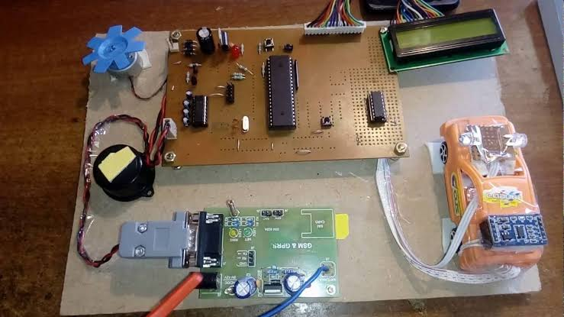

Broadly speaking, our proposed solution to address any accident which occurs will consist of four main units:

* Vehicle unit
* Detector(sensors)
* GSM module
* Hospital unit

All the components are placed in the middle of the car so when an accident takes place, the unit will be safe and it will work properly to save the victim's life . As soon as an accident takes place, all the sensors (accelerometers, fire sensor, gyroscope sensor, vibrational sensor) will detect it and record the intensity of the accident.

The basic workflow of our project is going to look similar to this. The system will start tracking as soon as the vehicle is started. Next, it will continuously get values from the sensor and if threshold value is reached for the system then an accident will be detected. This will be followed by an alarm for 10 seconds. This alarm is generated to check if the system has rightly detected the accident. In case it’s a false alarm then the user can turn it off. As soon as an accident is detected successfully the important data retrieved by the sensors about the health of the driver will be sent to the nearest hospital using the GSM module. The location coordinates (through GPS sensors) of the accident site will be sent along with this data to the nearest hospital so that they can send an ambulance as quickly as possible.

Uses of some of the major sensors of our system are mentioned below:

**Accelerometers Sensor** **:-** When accidents take place Accelerometers sensor detect the vibration which is caused by sudden decrease in speed of car and give signal to main unit.

**Gyroscope Sensor :-** This sensor measures the orientation of the vehicle.If the intensity of the accident is too high Gyroscope sensor will collect data of how many times the car rotated and how much was the intensity of the accident.

**Vibration sensor :-** This sensor is used to measure acceleration, pressure, temperature, force and electrical charge. Vibrator sensor is suitable for high frequency vibrations.

**Buzzer :-** Even for a low intensity signal, the led starts glowing and the buzzer makes noise(at this point the user has a choice to press the push button if he feels that the accident is not so severe and there is no need to call an ambulance).

**GPS Sensor :-** The signal is now sent to a GPS sensor which records the latitude and longitude of the place and sends it to the GSM module.

**GSM Module :-**  GSM Module provides a data link to a remote network. From here, the GSM module sends a signal to the hospitals which have a receiver’s end of the GSM Module. This all is coordinated by the Microcontroller board. The GSM module has a sim card which is used to send a message "Accident" (inputted by the user) to the prespecified persons (whose number was inputted by the user earlier). As soon as the hospital receives the signal a microcontroller and level control will convert it into human readable format and give proper address to the ambulance driver.

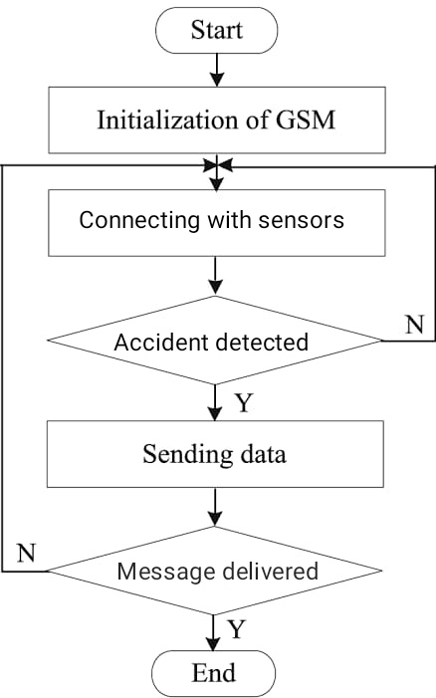

**Fire sensor :-** The fire sensor will detect the fire if there is anyand accordinglysend a message to the fire station.

If a particular(nearest) hospital is unable to respond and send an ambulance to the accident site, it can divert the message to the next hospital. This will be done using an **application** which has the database of all the hospitals, number of ambulances and their locations.

Finally, the hospital will dispatch the ambulance to the accident spot and provide necessary medical assistance to the injured to save their lives.

Additionally to our main system, we have a hand band which is equipped with a pulse rate sensor to monitor the heart rate of the person wearing it.

In the worst case scenario, if our system gets damaged, the user can press a push button on this band to send a message to the pre-specified persons( inputted by the user), this will be done using ESP8266 node MCU sensor fitted in the band.

Our motive is to save the precious lives of the people at all cost.

**Budget:**

Microcontroller boards:284

Accelerometer:214

Gyroscopic Sensor:125 Rs

Vibration sensor:293Rs

GPS Module :-3,089 Rs

GSM Transmitter:- 450 Rs

LED: 89Rs

Buzzer:199 Rs

RF transmitter:399 Rs

GSM receiver:290 Rs

IR Fire Sensor:- 105 Rs

Digital LCD Board:- 1028 Rs

Wifi Development Board:-275 rs

Other expenses=1235 Rs

Total=8180 Rs

**Work to be done in Coming Semester:**

In the coming semester as soon as we reach the campus our first aim is to collect all the necessary materials.To make the Iot system work the programming language of arduino should be understood and practiced well.After collecting all the materials our aim will be to to make a proper circuit diagram which includes all the sensors and other components with the help of various circuit simulators like Tinkercad to avoid any mistakes in the final physical circuit.After successfully making the circuit in the simulator ,the physical circuit shall be made including all the components.After making the physical circuit without any errors the circuit shall be tested on a toy car.

**Contribution of group members:**

**Rohit Doriya (B20AI034)**

My major contributions in this project were: health monitoring band to be worn by the driver, presented work flow of our project, contributed the statistics of major causes of accidents in India, presented the working of major sensors in the system, fire sensor addition and contributed to the final solution of the report.

**Shrutayu Aggrawal(B20ME073)**

My major contribution was: microcontroller working how data is converted to readable form, presented the flowchart of the microcontroller setting, proposed idea of eye detector but was rejected due to issues, contributed to the Ideation and proposed solution.

**Sukhmanpreet Singh Sandhu(B20CS073)**

My major contributions in this project were : proposed the idea of controlling traffic light signalling for emergency ambulance, presented the accident detection accuracy chart , contributed to motivation by providing accident related stats and contributed to the Ideation and proposed solution in the final report .

**Nitya Anand Shah (B20CS039)**

My major contribution in this project were: the interconnection between ambulances and hospitals with each other to increase the efficiency of work, presented the way previous and new records can be monitored and stored to retain referential integrity for data, contributed to the final report by elaborating the problem statement and main motivation behind this project.

**Saurav Kumar(B20BB037):-**

My major contribution in this project were: working principle of sensors, that is how the sensors will work , showed the working conditions of the sensors that is simulation of circuit in normal conditions, firing conditions, conditions before reaching the ambulance and the conditions after the reaches the ambulance and advantages of automatic ambulance signaling systems.

**Nitesh Meena (B20CH025):-**

My major contribution in this project is to find sensors and other things , collect data of parts and help to find their working and find their price and availability for this project , listing the price of each component and making a budget , explaining the working of parts in the final solution .

**Mohit Mathuria (B20BB022):-**

My major contributions in this project were: Proposed the safest spot in the car where the main system can be placed, refined the idea of band to a smartwatch acting as a sensor for monitoring heartbeat and temperature related data of the driver.

**Abhishek Kumar (B20ME003):-**

My major contributions in this project were: proposed the idea to inform nearby vehicles about the accident , how we can detect the presence of a person inside the car during the impact and contributed to background research of this project.

**Tanisha Jain (B20EE072)**

My major contributions in this project were: establish a communication network between vehicle unit and ambulance unit using GSM module, addition of vibration sensor, designed the prototype of the model, redefined the idea of hand band to include a sensor to give message to the prespecified persons, contributed to the final solution in the report.

**Devyani Gorkar(B20ME027)**

My major contributions to the project includes: I made the decision matrix in the report, Contributed majorly in slides,combined all the sensors,did editing in the report and slides to make it look better.Collected flow charts to add in the slides.

* **Contribution report- Devyani Gorkar(B20ME027)**

1. Presented The idea:

I have observed this problem manier times since I have come across people who lost lives just because they didn't receive proper treatment in time.The increasing no. of vehicles is increasing the risk of losing of lives at grater pace

1. Presented the Basic solution:

The main aim of this project is to save lives of victims by removing the time and communication gap that arises between the victim and hospital system because of the manual system. It can be made automatic ,using some sensors which will detect the accident .For eg. gyroscopic sensors and accelerometers.Gps tracker will collect the latitude and longitude of that position and send it to the nearest hospital system by GSM module.Using that location the ambulance will reach the victim.

1. Presented the idea of buzzer:

Many times due to absence of street lights or absence of headlights of vehicles the passerby cannot see the accident.To prevent this and to make people aware of this a buzzer will beep as soon as the threshold of the sensors exceed.

1. Informing family member:

As soon as the accident is detected by the sensors a message will be sent to the family member using the GSM module.

1. Written the complete decision matrix in the final report from the ideas and solution so as to complete the finalising of the proper solution

**Contribution Report- Shrutayu Aggarwal(B20ME073)**

I have worked in the “**Automatic Ambulance Signaling Project”** and my major contribution in this project are listed below:

* Proposed the idea of an eye detector but due to various disadvantages it was rejected.
* Explained the microcontroller working and presented a flow chart of it. As soon as the hospital receives the signal, a microcontroller and level control will convert it into human readable format and give proper address to the ambulance driver.
* Proposed to install a buzzer in the ambulance as until the ambulance reaches the victim, the buzzermust create a beep sound and blink some lights to create awareness about the accident to the passerby. This is important because then only people would be able to come forward and help the victim in case he is in a severe condition and needs immediate help.
* Worked behind the ideation and the proposed solution in the main report (Gave all my explanation in the main report).And also prepared the rough flowchart of sensors to make group members aware of their working.
* Proposed how the GSM module would work and how the data is to be transferred.

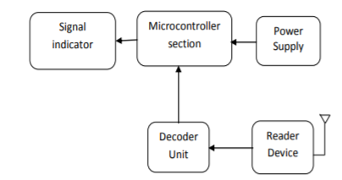

**Nitesh Meena (B20CH025):-**

**Contribution Report – Nitesh Meena (B20CH025)**

My major contribution in **“AASS” (Automatic Ambulance Signaling System)** are following:-

1. Find parts and other components for this project.

2. Help to find the working of sensor and other components

3. Stripping the component which is not more useful.

4. Making some research on the part selected will work properly in a hazardous condition.

5. Find the availability of the product.

6. Find the price of parts and other components with help of the internet.

7. Try to find parts and their price in the local market.

8. Make a budget list of every component and keep eye on the final billing should be under our budget.

9. Make some edits to the final report as needed.

10. Help to explain the working of this project in the final solution section of the final report.

The link of budget for this project is following:-

<https://docs.google.com/document/d/1fu7he_u2VuKOWnm2gFdkkWUgUcL8xJBrVgMTtghtAek/edit?usp=sharing>

**Contribution Report -- ABHISHEK KUMAR (B20ME003)**

I have worked in the **“Automatic Ambulance Signalling Project”**. I took part in the group discussion of our group and suggested some ideas and had a good discussion about the project to make it better. My major contribution in these project are listed below:

* Proposed the idea to inform vehicles of some distance about the accident. So that the way of the ambulance can be cleared. But this idea has some disadvantages. So, this idea was rejected.
* Proposed the idea of a weight sensor to determine whether any person is present in the car or not. But due to some disadvantages this cannot be implemented.
* I had also worked behind background research in the main project along with Mohit.

**Contribution Report - Saurav Kumar (B20BB037)**

I have worked on an automatic ambulance signaling system . My main contribution in this project is the simulation of circuits in normal condition, firing conditions, ambulance before reaching and ambulance after reaching.

**Simulation Result** : I have also contributed the simulation result conditions in various situations.

* **Normal Condition** : In normal condition the vibration sensor and fire sensor value will be less than the preset value that is all the components are in inactive mode.
* **Accident condition** : If a vehicle has met with an accident, the vibration sensor gives the electric signal to the microcontroller through signal conditioner. GPS provides latitude and longitude information about vehicle location to control sections through GSM.
* **Fired condition** : If a vehicle has met with an accident, the fire sensor gives the electric signal to the microcontroller through signal conditioner.
* **Before the ambulance reaches the traffic signal**: Before the ambulance reaches the accident place , the led on sensor will grow red. On display , a message will appear that says “ accident met!”. Control section transmits the control signal to all the signals in between ambulance and vehicle by RF transmission.
* **After ambulance reaching traffic signal**: After ambulance reaching the accident place junction , the led on sensor will glow green. On display, it will show the message that “person found !” . and all this will done with the help of the RF signal

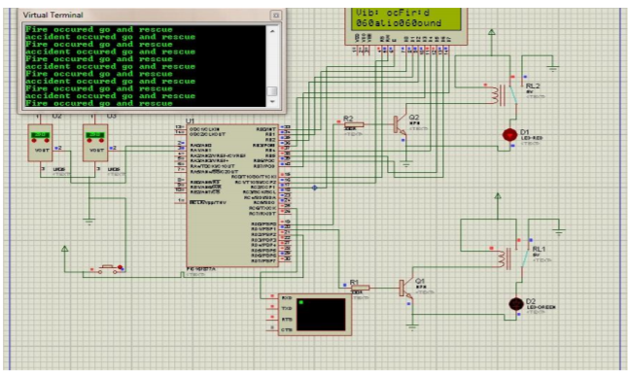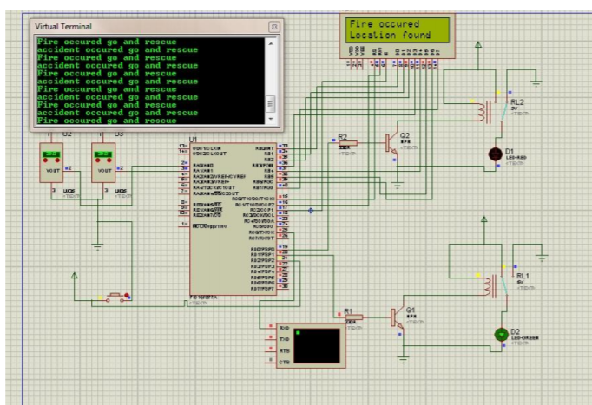

Before accident and ambulance is after accident and ambulance is not reached reached

Also my contribution is to showing final model of sensor with help of arduino and mobile location tracking through gps.

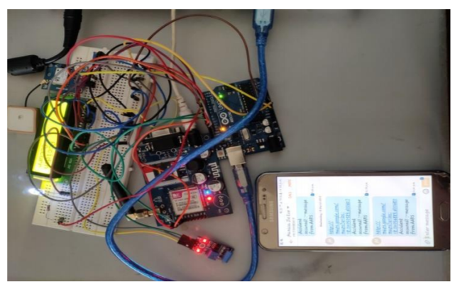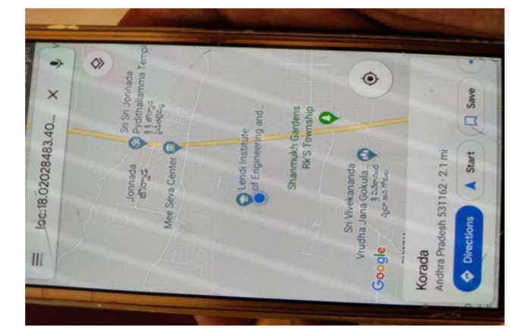

Accident alert message Accident location tracking through GPS

**Contribution Report - Rohit Doriya (B20AI034)**

I have worked in the “Automatic Ambulance Signalling Project” and my major contribution in these project are listed below:

* Contributed to show the real statistics of road accidents in India so that we could take appropriate decisions to design our system based on real problems faced by people after an accident. The references were: <https://bit.ly/3fEnhEp> and <https://bit.ly/3yyk024>.
* Suggested to add a fire sensor in our system since it often happens that the vehicle catches fire after an accident. To track this we needed a fire sensor.
* Presented the working of major sensor components of our project namely accelerometer, gyroscopic sensors, GSM module, GPS sensor and Fire sensor.
* Prepared a work-flow chart of the working of our automatic ambulance signalling system. It gave the complete overview of the project in one image.
* Suggested the idea of health tracking bands to be worn by the vehicle driver so that we can track his health status and accordingly inform the hospital so that they can come prepared with essential medical equipment at the site of accident.
* Contributed the final solution in the group report.

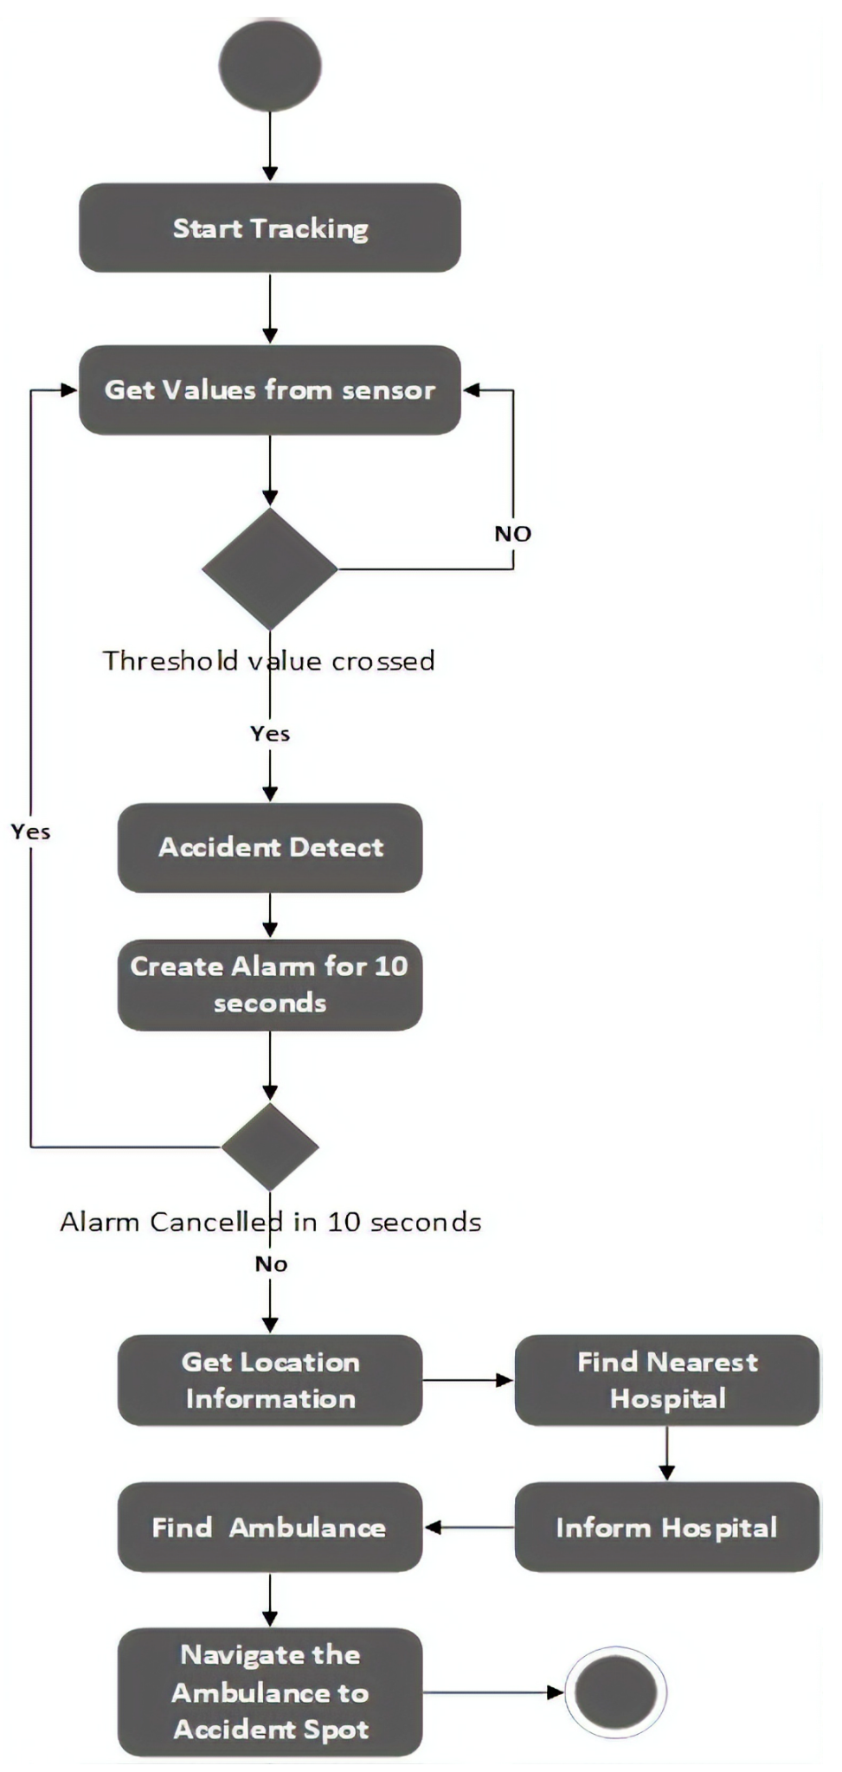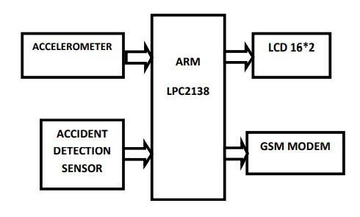

AUTOMATIC AMBULANCE SIGNALLING PROJECT

***Contribution report - Nitya Anand Shah***

I have worked in the “Automatic Ambulance Signalling Project” for the Engineering Design I and II this semester. My major contribution in these project are as below:-

1. Interconnection between hospitals and ambulances:-

An app is proposed with the major role of ECS (Emergency Communication System) to play.Sufficient medical equipment to provide medical support to the individual en-route to the hospital on the ambulance, a skilled medical team that is trained and efficient and capable ambulance driver make a better team.The primary function of ECS is to make sure that the one-way and two-way communication between the ambulance staff and the hospital and with other local hospitals. It ensures the paramedics on the ambulance and the medical team at the hospital work as a team without any communication gaps. The real-time communication between both the parties helps to understand and analyze the exact scenario and take medical actions. Even in case of severity a new team can be organised and sent to action almost immediately decreasing fatality due to accidents.

The communication can be smoothened between hospitals and ambulances using following-

i)Operational Communication Equipment (OCE):-

The communication receivers and the senders help the operational team in understanding the real-time scenario.

ii)Integrated Medical Computer and Network System:-

It is not an instrument but the mechanism that receives, comprehends and sends the appropriate messages.

iii)Global Positioning System (GPS):-

The satellite-based navigation system let the hospital team know the exact location of the ambulance. It also helps the driver and the emergency or the operator to analyze and find the best way to reach the hospital while reducing the time of journey significantly. The advanced system foresees the traffic, road-blocks and communicates the same to the driver.

1. Managing the data feeds of daily accidents.:-

Storing old cases might not always do good, it can take a lot of space and thus not allow new cases to register.All too often a program itself deletes something accidentally and needs it replaced easily. It also helps retain referential integrity for related data. We can have new cases and monitored and stored and at the same time delete the ones too old or not of any use to maintain space and records.

c).Elaborated the problem statement and main motivation behind our project in the final report

Automated Ambulance Signalling System--Sukhmanpreet Singh Sandhu(B20CS073)

My major contributions were--->

1. *Proposed a traffic controlling system* --> The proposed system included two parts; ambulance and data center. The ambulance would contain the hardware unit that would collect the GPS signals and then sent them to the webpage of the datacenter in which they would be saved in database later. The data center would implement the changing of traffic light control algorithm that gives green signal when the ambulance is nearby. Additionally, the selecting of optimal path from patient to hospital locations and in the opposite direction would be performed at the data center depending on the crowd sensor readings fixed at the roads. This idea was rejected because of the complexity involved.
2. *Accident detection and it’s accuracy* --> I presented in class the accident detection mechanism and factors which contribute to its accuracy. The crash sensor is the classic application found in automotive systems for accident detection. It mainly consists of MEMS (Micro-electro-mechanical systems) inertial sensors (accelerometers and gyroscopes). The accelerometer continuously measures the acceleration of the car. When this parameter exceeds a predetermined threshold, a microcontroller unit (MCU) calculates the integral of the acceleration to establish if a considerable speed variation has occurred. Alternatively, I suggested implementing angular speed sensors into the design. I showed a chart to prove that accident detection accuracy is maximum when we use a combination of speed,noise, accelerometer and pressure sensor. It has been added at the end.
3. *Ideation and proposed solution* --> In the final report I contributed in explaining the various ideas in brief . These included :

* Informing family members as soon as the accident takes place which is vital in saving the victim’s life. It would be done using GSM Module.
* Explaining importance and use of fire sensors . It will detect fire and accordingly send signals to the fire fighters so that they can arrive on time and rescue the victim.
* Making an application which would alert vehicles within 500 m of radius so that they can give side to the ambulance.
* Preventing unnecessary ambulance calling by having a 10 sec alarm system. This alarm could be turned off by the victim within 10 in case he feels that it is not necessary . If he does not do this within 10 sec then a message will be sent to call the ambulance .
* Installing a buzzer system to create awareness among the passerby’s after the accident has occured.

*chart comparing accident detection accuracy in various cases*

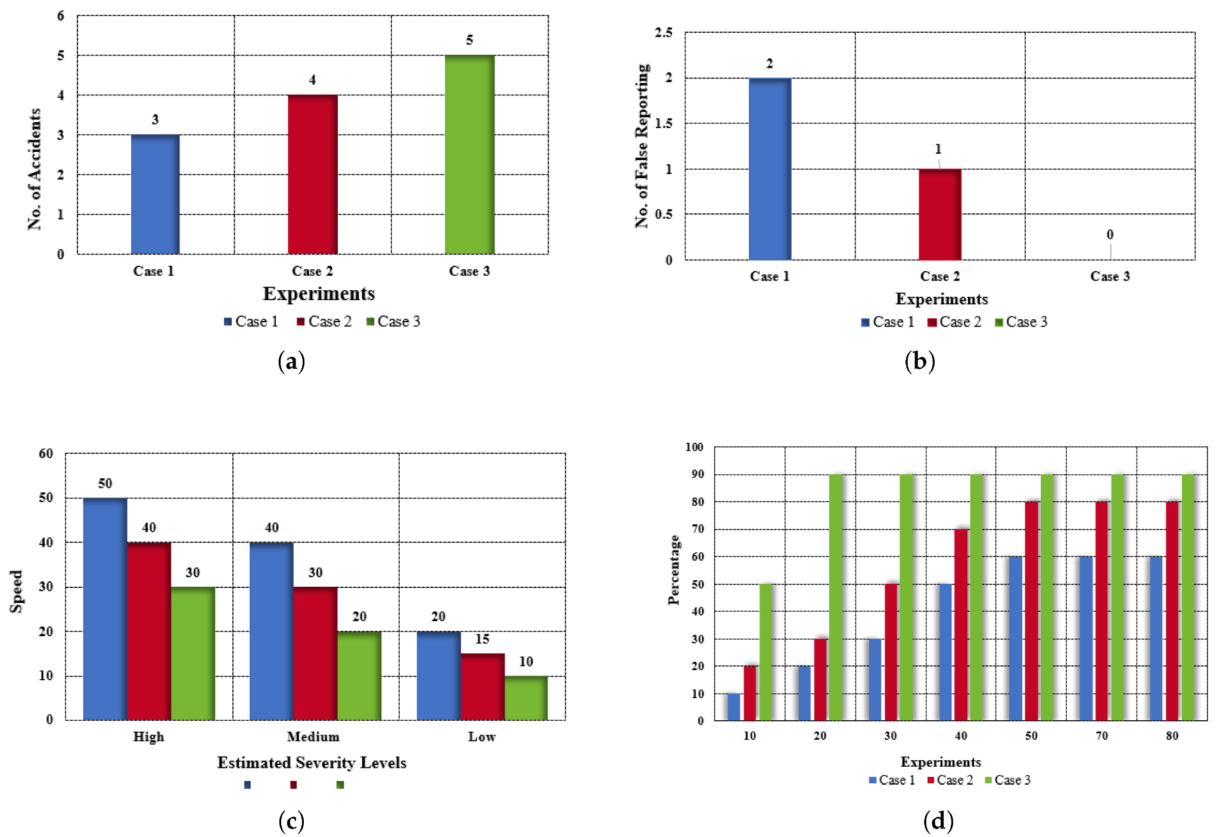

**Contribution report - Tanisha Jain (B20EE072)**

In Engineering design-I course, I worked in the "**Automatic Ambulance Signalling System**" project and my major contributions towards this project are listed below:

* Establishing a **connection** between the **vehicle unit** and the **hospital unit**. This is achieved using a **GSM(Global System for Mobile communication)** system.

It has a wireless modem, designed for communication over the GSM and GPRS network. It requires a SIM (Subscriber Identity Module) card just like mobile phones to activate communication with the network.

Our GSM module will receive signals from the various accident detection sensors, and if the intensity of the accident is above a pre-set value, the system starts operating and detects an "Accident". It sends the recorded data to the receiver's end of the model which is installed in the hospitals.

Reference for detailed working: <https://www.google.com/amp/s/www.electronicsforu.com/resources/gsm-module>



* Addition ofa **Vibration sensor**.

Using a vibration sensor can increase the accuracy of accident detection.

Vibration sensors have a transducer that converts mechanical force caused by vibration or a change in motion into an electrical current using the piezoelectric effect. It is also suitable for high frequency vibrations.

* Suggested to add **ESP8266 node MCU sensor** to the idea of health hand band.

In the worst case scenario, if the system fails to operate, the person can press a push button present on the hand band and using ESP8266 sensor, a message will be delivered to the pre-specified contacts.

* Compiled all the ideas and helped analyze the pros and cons of different sensors to be used in order to improve the **efficiency** of our system.
* Design of **prototype** of the model.



* Contributed to the **final solution** in the main report.

**Contribution Report - Mohit Mathuria (B20BB022)**

In this report I am going to describe my own role in helping the team to achieve its goal in relation to the team report. In this semester's integrative core session of engineering design, I was working on the “automatic ambulance signaling system ”.

I participated in the group discussions conducted internally within our group and raised my concerns and views regarding any new addition of component in system (I presented my views on the feasibility of this addition like if it is implementable and how much useful could it be) in friendly manner and provided as much as my analytical view on it as possible. I also proposed that the safest spot where the main system component (that will send a message if a car meets a crash or accident) can be placed is “middle rear seat in the car”. I also modified the idea of placing a band on the driver's wrist that will monitor his/her heartbeat (that originally Rohit Doriya proposed) with the idea that the band rather than made by us will be a premade smartwatch acting as a sensor to monitor the drivers heartbeat and temperature data. I have also provided a picture of such a smartwatch which we used in slide presentation. Other than these I did the background research along with Abhishek which is in the group report.